Daniel McDonough

4/20/18

Bio Sim

Reflection 2

Current Progress:

* Swapped Topics from Protein Synthesis to SLE Testing
* Researched the autoimmune system pathway and it’s effects with lupus
* Modeled Necrosis/Apoptosis
* Included all currently known agents except testing agent (in code)
* Included a predisposition button

Strategies Used:

* Looked for more visual explanations of the pathway system
* Looked at HCI components for visualized the pathway system in a balance of readability and accuracy
* Thought of all major players in the simulation and if they should be agents or fields/attributes

Week Plans:

* Develop interactions between agents further
* Fix recognition of antigens bug where color constantly grows by 2

Updated Abstract:

**Simulation in Biology Project Abstract**

**Group:** Cellular Biology

**Project name:** Systemic Lupus Erythematosus (SLE)

**Student name:** Daniel McDonough

**Project description:**

The immune system relies on several cells signaling to one another and passing information, but when distorted, this signaling can result in unintuitive processes. Systemic Lupus Erythematosus (SLE), tricks antibodies into attacking healthy cells. The normal pathway is stimulated by an unknown cause but predispositions are known. This unknown cause makes cells apoptotic and release DNA during cell death. This DNA is sometimes picked up by a dendritic cell and is recognized as foreign and activates a cascade of T-cells to B-cells who then release corrupted antibodies who attack the hosts’ healthy cells all across the body..

This simulation will look at what would happen across several positions in the SLE pathway and hope to add preventative measures to parts of the pathway in hope to model a theoretical solution to SLE. Possible by adding other proteins such as Anifrolumab on the T-cell receptors inhibiting the production of antibodies.

**Agents and rules:**

*Healthy Cells:*

1) Agents representing healthy tissue on the top of the screen

2) Have a chance of becoming Apoptotic (increased by switching on predisposition)

3) Once Apoptotic, it will slowly grow over time until it “pops” and releases DNA

4) While being apoptotic, a dendritic cell can eat it.

5) Can spawn in place of dead cells to simulate healing

*DNA (Antigens):*

1. Nucleic bits that signal “danger” to APC based on a chance of external factors
2. Can be discovered by APC, B-cells and antibodies
3. Can target dsDNA, or Smith

*APC & Phagocyte (Dendritic cells):*

1. Can gather Antigens and pass on the info to helper Tcells
2. Eat Apoptotic cells

*Bcells:*

1. Agents that recognize nucleic antigens
2. Produces corrupt antibodies in response of the detection of the antigens
3. Can recognize the same info from Tcells

*Tcells:*

1. Transfers info between APC and Bcells
2. Able to be “vaccinated” to prevent the transfer of auto-antigens

*Antigen-Antibodies:*

1. Holds the dna of the antibody that caused it to spawn
2. Attacks all other cells with the same dna

*Anifrolumab:*

1. Attaches to Tcells and prevents them from transferring info from the Dendritic Cells

**Model validation:**

1. The Antibodies are able to destroy healthy cells
2. Cells replicate
3. Cells die over time

**Hypotheses / Predictions:**

1. By inhibiting one common point of lupus it is possible to slow down or completely stop the inflammation/damage to healthy cells

**Evaluation (graphs, statistics):**

1) Amount of corrupted antibodies

**User Interaction (sliders, buttons):**

1. Predisposition button that effects the rate of apoptosis
2. Amount of UV light
3. Tcell vaccination button

**SLE Pathway**:

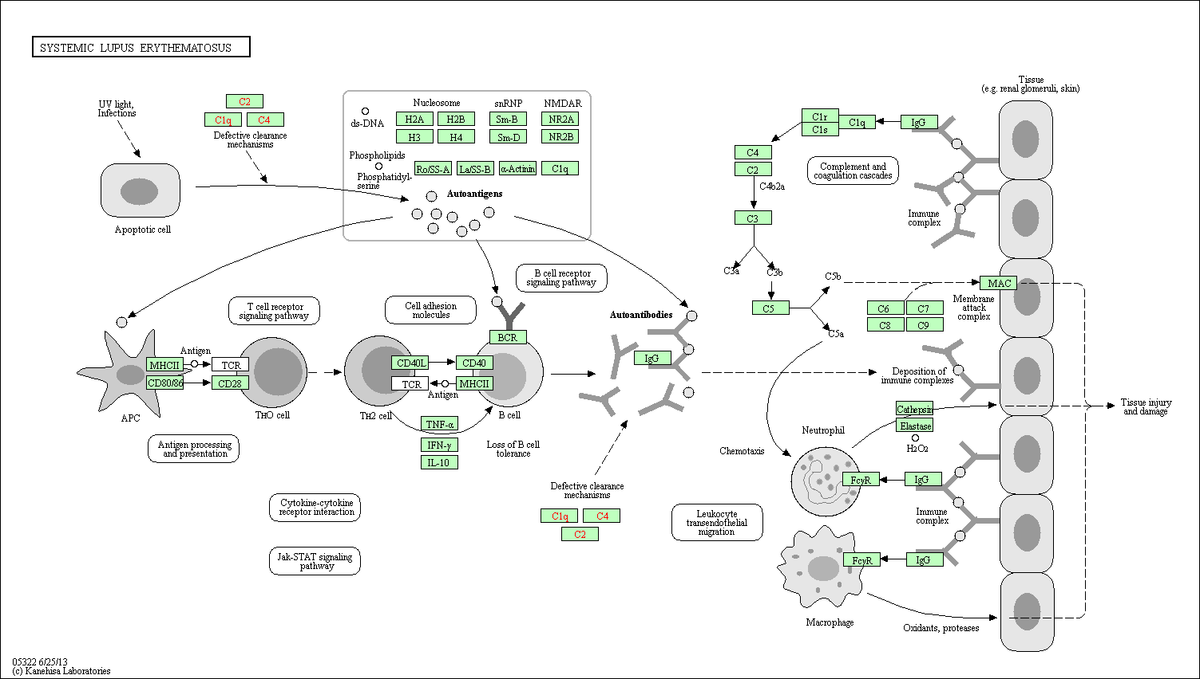

**References:**

* <https://en.wikipedia.org/wiki/Antigen-presenting_cell>
* <http://www.genome.jp/kegg-bin/show_pathway?org_name=hsa&mapno=05322&mapscale=&show_description=show>
* <https://en.wikipedia.org/wiki/Antigen-presenting_cell>
* <https://www.youtube.com/watch?v=23M35omW6H4>
* [https://www.astrazeneca.com/media-centre/press-releases/2015/AstraZeneca-presents-positive-new-data-on-anifrolumab-in-lupus-at-American-College-of-Rheumatology-Annual-Scientific-Meeting-10112015.html#](https://www.astrazeneca.com/media-centre/press-releases/2015/AstraZeneca-presents-positive-new-data-on-anifrolumab-in-lupus-at-American-College-of-Rheumatology-Annual-Scientific-Meeting-10112015.html)!